# **Travelers Hub Application - Django Basics Retake Exam**

**13 December 2024**

*The app allows user to browse trips, including their summary, destinations, and images. The user can create, edit, or delete trips. Users can also see, edit, or delete their traveler's profiles.*

## Skeleton

All essential **HTML** pages, **images**, and **CSS** resources for the project have been provided to you.

## Structure

Establish a well-organized project structure by initiating **at least** **two** Django **apps** and configuring the **corresponding URLs**.

You have the flexibility to utilize **both** **Function-Based Views** and **Class-Based Views** as needed.

Adhere to best practices and uphold the separation of concerns principle for a robust and maintainable codebase.

If there are **no explicitly** **defined** requirements for formatting or additional functionalities, it implies that **you** **are** **not obligated** to **implement** **them** unless you have ample time and wish to enhance your project. However, **ensure** that you **fully satisfy** **all explicitly defined** ones.

## Database

You will need **two models**:

### Traveler

* + **nickname**
    - **Character** field, **required**, **unique**.
    - It should consist of a **maximum of 30 characters and** a **minimum of 3 characters.**
    - The nickname **can contain only letters and digits**. Otherwise raise **ValidationError** with the following message: "**Your nickname is invalid!**"
    - Help text: **"*Nicknames can contain only letters and digits."**
  + **email**
    - **Email** field, **required**, **unique**.
    - It should consistof a **maximum of 30 characters**.
  + **country**
    - **Character** field, **required**.
    - It should consist of **exactly 3 characters**.
  + **about_me**
    - **Text** field, **optional**.

### Trip

* + **destination**
    - **Character** field, **required**.
    - It should consist of a **maximum** of **100 and** a **minimum of 3 characters**.
  + **summary**
    - **Text** field, **required**.
  + **start_date**
    - **Date** field, **required**.
  + **duration**
    - **Positive small integer** field, **required**.
    - **Default** value: **1**.
    - Help text: **"*Duration in days is expected."**
  + **image_url**
    - **URL** field, **optional**.
  + **traveler**
    - A **foreign key** to the **Traveler** model.
    - Establishes a **many-to-one** relationship with the **Traveler** model, associating each trip with a traveler.
    - The **ON DELETE** constraint must be **configured** to an **appropriate value** in alignment with the specified **additional tasks**.
    - This field should remain **hidden** in forms.

**Note: Validations will be assessed solely on the user side, with no evaluation from the Admin site**.

## Routes

* <http://localhost:8000/> - Index page
* <http://localhost:8000/all-trips/> - All Trips page
* [http://localhost:8000/trips/create/](http://localhost:8000/posts/create/) - Trip Create (Share) page
* [http://localhost:8000/trips/<trip_pk>/details/](http://localhost:8000/trips/%3ctrip_pk%3e/details/) - Trip Details page
* [http://localhost:8000/trips/<trip_pk>/edit/](http://localhost:8000/trips/%3ctrip_pk%3e/edit/) - Trip Edit page
* [http://localhost:8000/trips/<trip_pk>/delete/](http://localhost:8000/trips/%3ctrip_pk%3e/delete/) - Trip Delete page
* [http://localhost:8000/traveler/create](http://localhost:8000/author/create)/ - Traveler's Profile Create page
* [http://localhost:8000/traveler/details/](http://localhost:8000/author/details/) - Traveler's Profile Details page
* [http://localhost:8000/traveler/edit/](http://localhost:8000/author/edit/) - Traveler's Profile Edit page
* [http://localhost:8000/traveler/delete/](http://localhost:8000/author/delete/) - Traveler's Profile Delete page

## Pages

### Base Template - 10p

**Template file**: **"base.html"**

Create a **base template** to be **inherited** by all other templates in the project. This base template should encompass project **metadata** within the <head> tag, along with a consistent **navigation bar** and **footer** for **each** web page.

**Navigation bar**:

* **Logo image** as link, that leads to the **Index** page.
* **"New Traveler's Profile"** link leads to the **Create Traveler's Profile** page.
* **"All Trips"** link, which leads to the **All Trips** page.
* **"Share Trip"** link leads to the **Create Trip** page.
* **"Traveler's Profile"** link leads to the **Traveler's Details** page.

**Footer:**

* **"&copy; 2024 Travelers Hub by SoftUni Team. All rights reserved."**
  + The **footer** is **consistent** across **all pages** and does **not change**.

Note that the **"New Traveler's Profile"** link on the navigation bar is **only visible** when the user **has NOT created** a traveler's **profile yet**, while the **"All Trips"**, **"Share Trip"**, and **"Traveler's Profile"** links are **only visible** when the user **has a profile**.

This template lacks a direct path and is **inaccessible** via **URL**.

### Index page - 5p

**Template file**: **"index.html"**

The page displays:

* A **navigation bar** as described above
* A welcoming **heading**: **"Wander, Explore, Share..."**
* An **image** that you have in the resources folder (static/images/logo-img-trip.png)
* A **footer** as described above

Keep in mind that the **"New Traveler's Profile"** link on the navigation bar is **only visible** when the user **has NOT created** a **traveler's profile yet**:

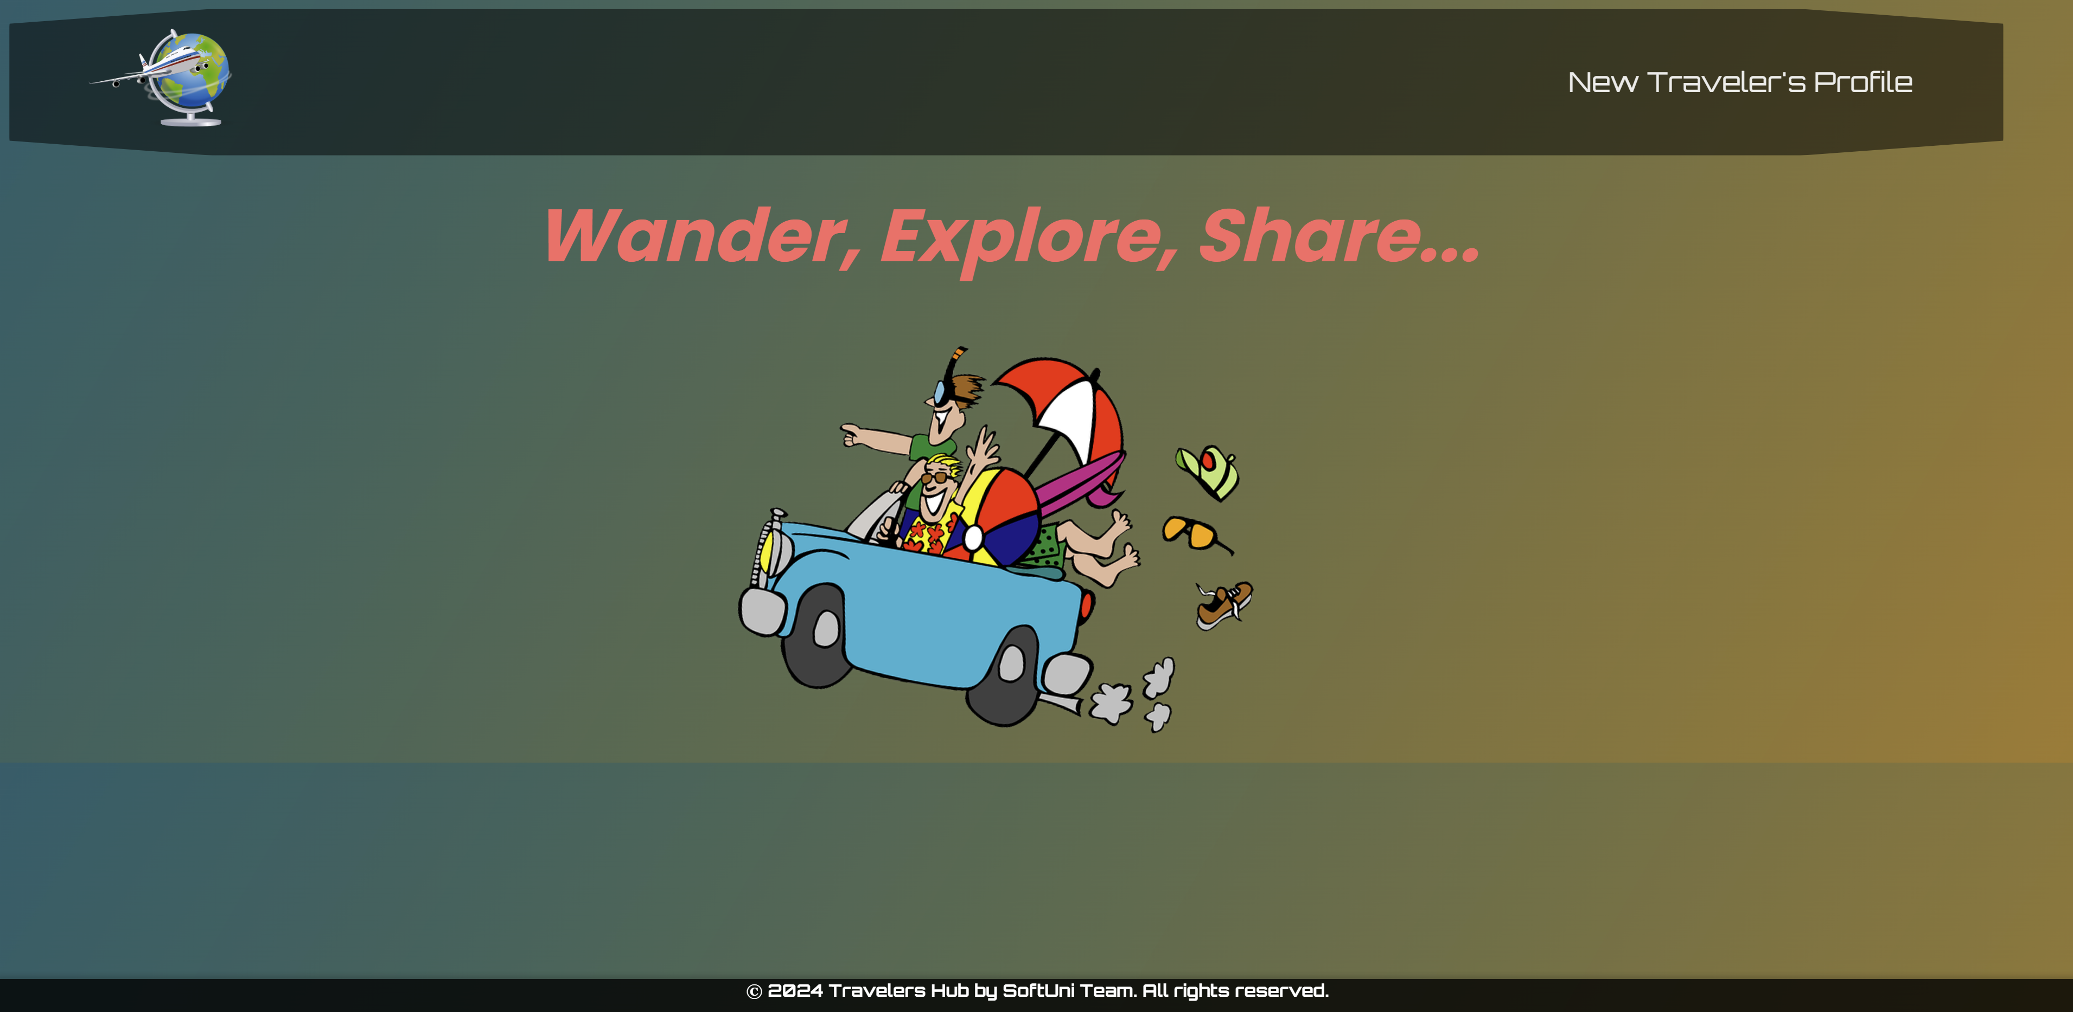

The **"All Trips"**, **"Share Trip"**, and **"Traveler's Profile"** links on the navigation bar are **only visible** when the user **has a traveler's profile**:

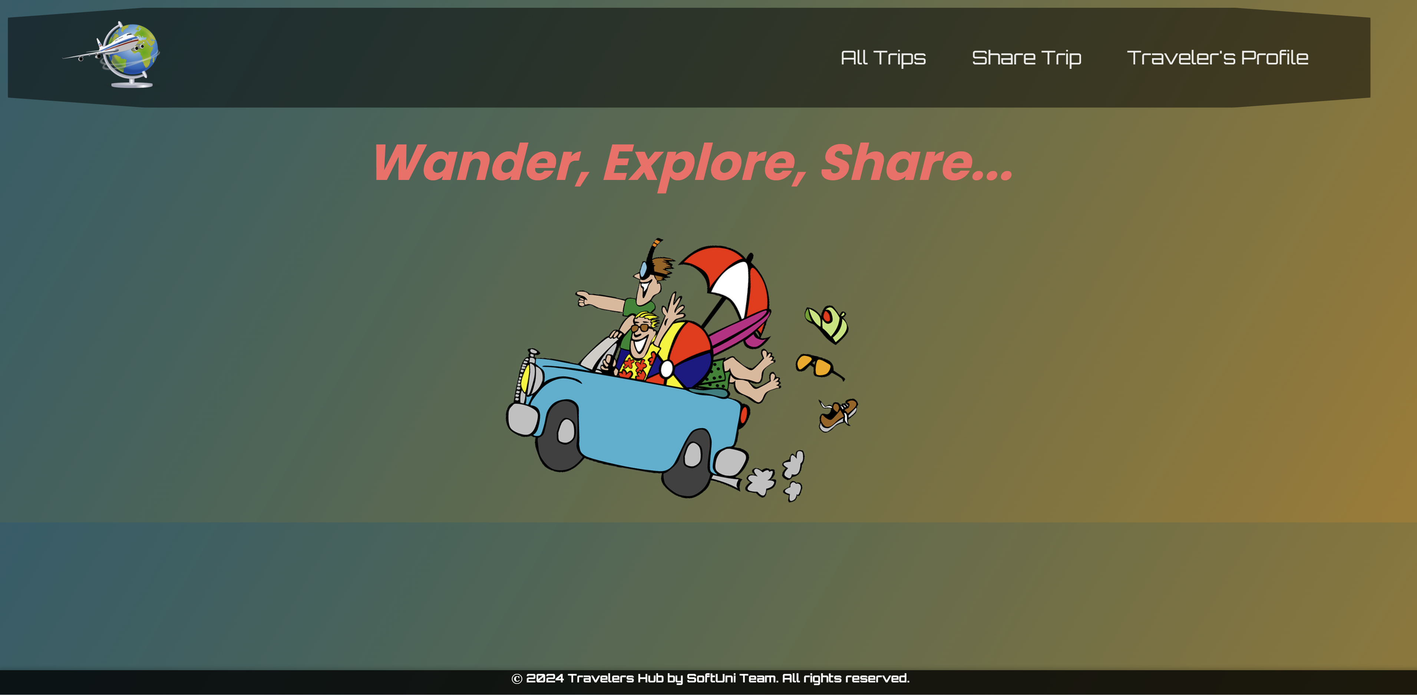

### Create Traveler's Profile Page - 10p

**Template file**: **"create-traveler.html"**

The page displays:

* A **navigation bar** with:
* **Logo** link, which leads to the **Index** page.
* **"New Traveler's Profile"** link leads to the **Traveler's Profile Create** page.
* A new **traveler's** **profile** **creation form** consisting of:
* A **"Nickname"** field with:
  + the **help text** **"*Nicknames can contain only letters and digits."**
  + a **placeholder** **"Enter a unique nickname..."**
  + a **label "Nickname:"**
* An **"Email"** field with:
  + a **placeholder** **"Enter a valid email address..."**
  + a **label "Email:"**
* A **"Country"** field with
  + a **placeholder** **"Enter a country code like <BGR>..."**,
  + a **label** **"Country:"**

A button **"Create"**

* When you **click** on it **if** the profile is **successfully created**, you should be **redirected** to the **All Trips page**.
* Otherwise, the form should show the **appropriate validation errors**.

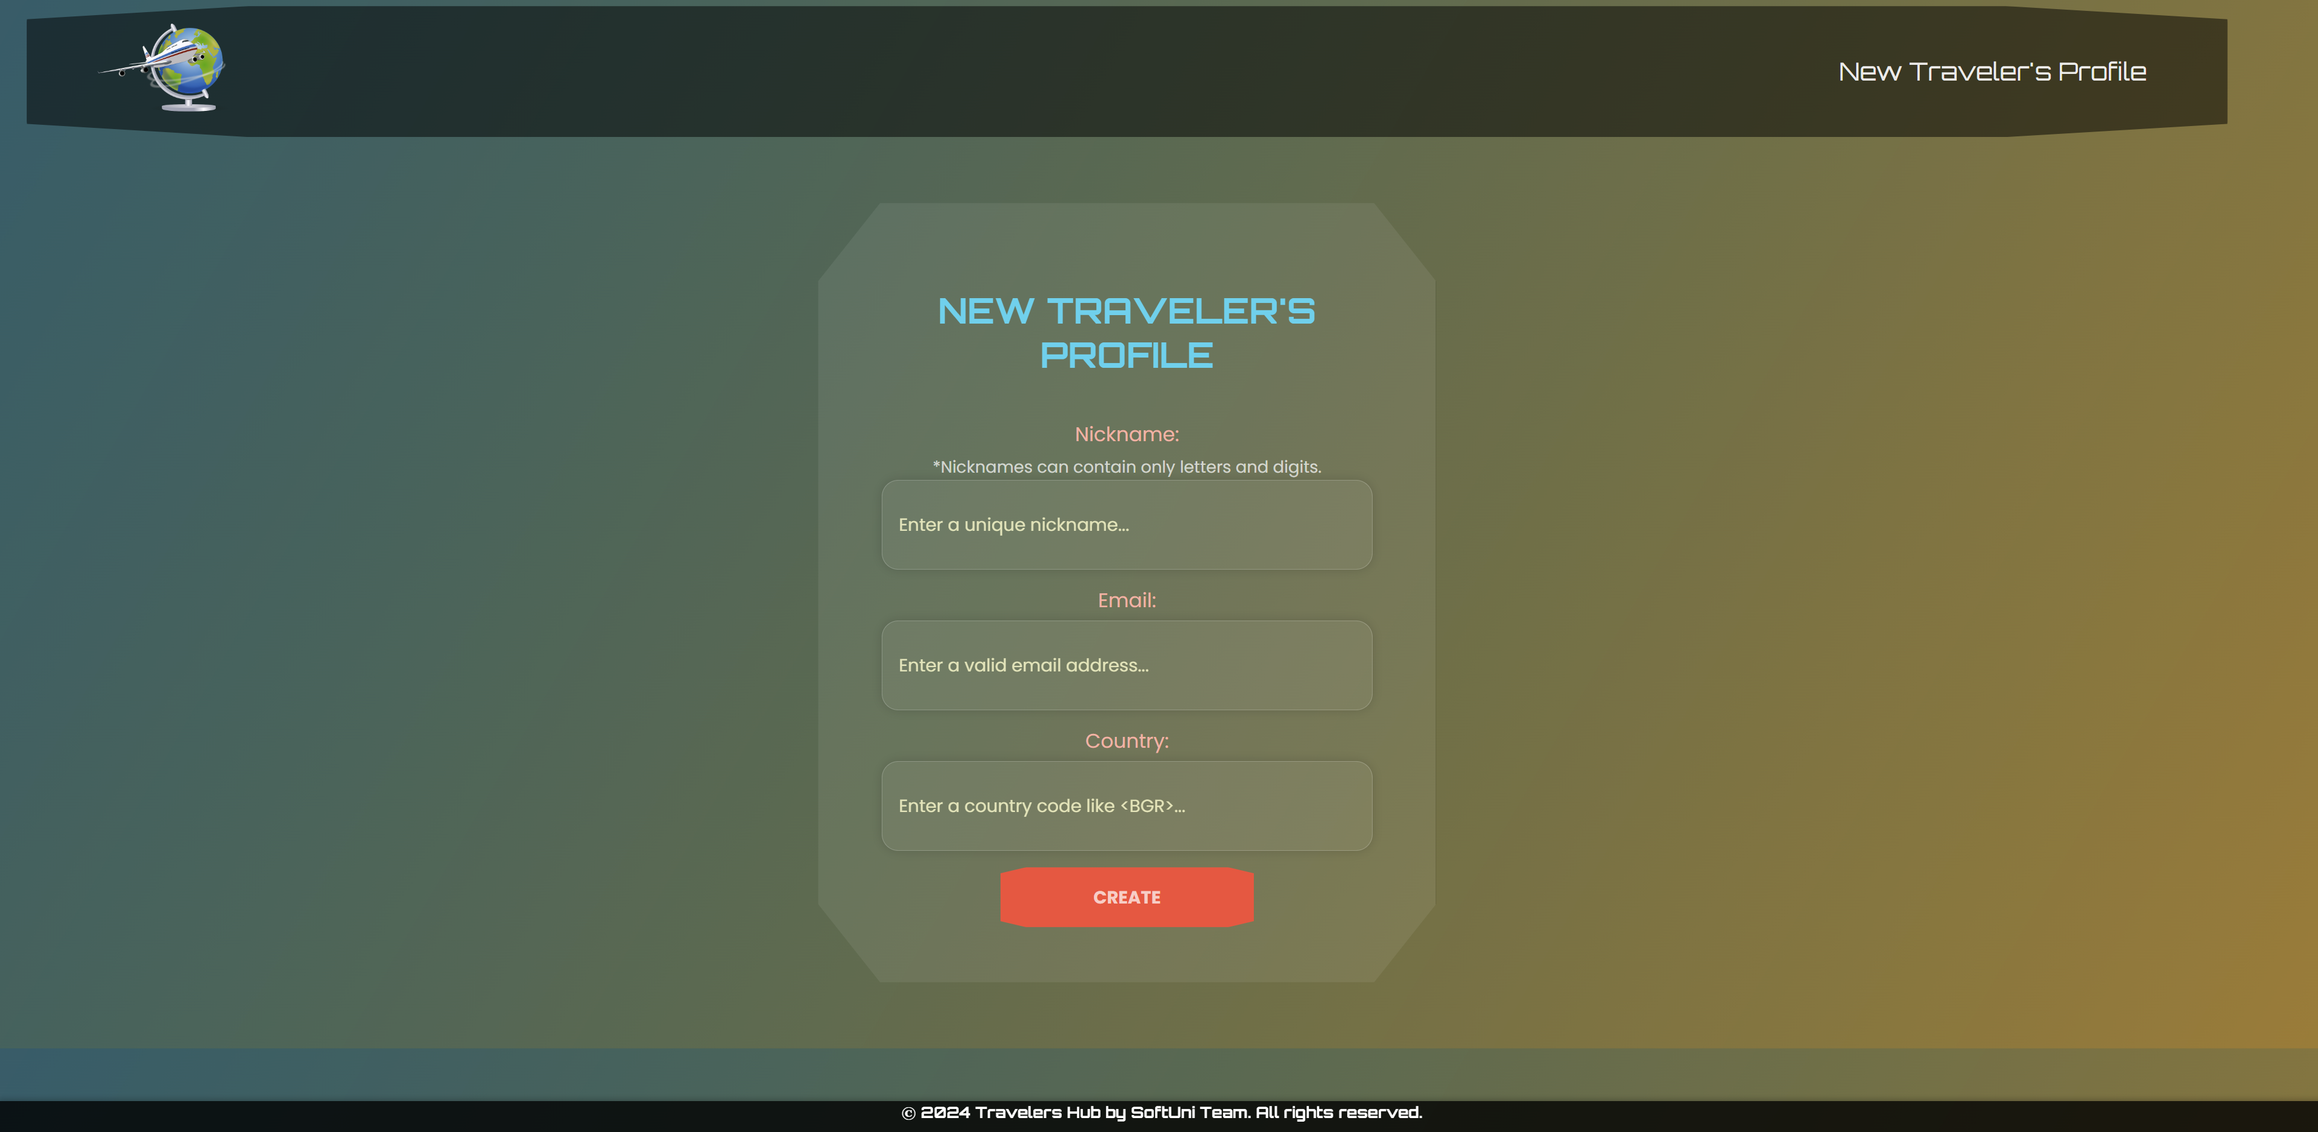

### All Trips Page - 10p

**Template file**: **"all-trips.html"**

The **page** shows **all trips created** and **stored** in the **database**, **ordered by start date descending**.

If there are **no trips shared yet**, the page should have the following:

* A **navigation bar**, as shown below.
* A heading **"No shared trips"**

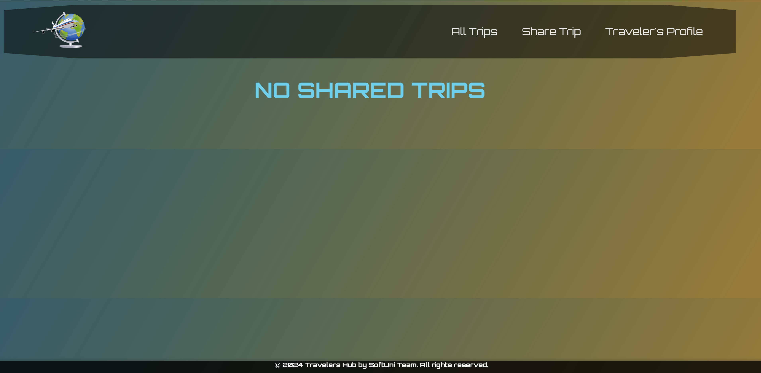

If there are **trips**, **order them by** the**start date descending**.The page should have the following:

* A **navigation bar**, as shown below.
* A heading **"<number>** **Shared Trips"**
* A card for **each trip**, showing:
* The trip's **image** if suchis **provided**, otherwise displays a **default trip image** from resources(static/images/default-trip.jpg)
* The trip's **destination**
* The trip's **start date**. The **date is displayed** in the **format**: **"D d M Y"**.
* A **button** **"Details"**, leading to the **Details page** for the **selected trip**.

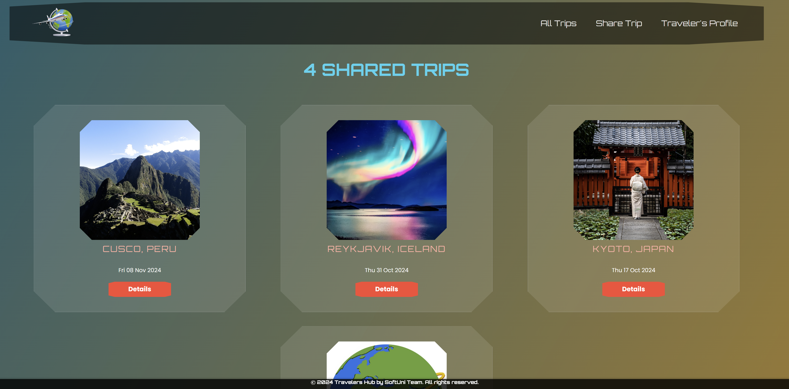

### Create (Share) Trip Page - 10p

**Template file**: **"create-trip.html"**

The page consists of:

* A **navigation bar**, as shown below.
* A new **trip** **creation form** consisting of:
* A **"Destination"** field with:

a **placeholder** **"Enter a short destination note..."**

a **label "Destination:"**

* A **"Summary"** field with:
  + a **placeholder** **"Share your exciting moments... "**
  + a **label "Summary:"**
* A **"Started on"** (start_date) field with:
  + a **label "Started on:"**
  + **Note**: Using the appropriate **widget** for **date inputs** and **showing** a **calendar date picker** is **NOT** **required** but is a good practice and facilitates users. You **are allowed** to leave it as a **simple date field**.
* A **"Duration"** field with:
  + a **help text** **"*Duration in days is expected."**
  + a **prepopulated default value**: **1**
  + a **label "Duration:"**
* An **"Image URL"** field with:
  + a **placeholder "An optional image URL..."**
  + a **label "Image URL:"**
* A button **"Share"**
* When you **click** on it **if** the trip is **successfully created**, you should be redirected to the **All Trips page**.
* Otherwise, the form should show the **appropriate validation errors**.
* **Associate** the new **trip** with the **traveler's profile** you already have in the database.

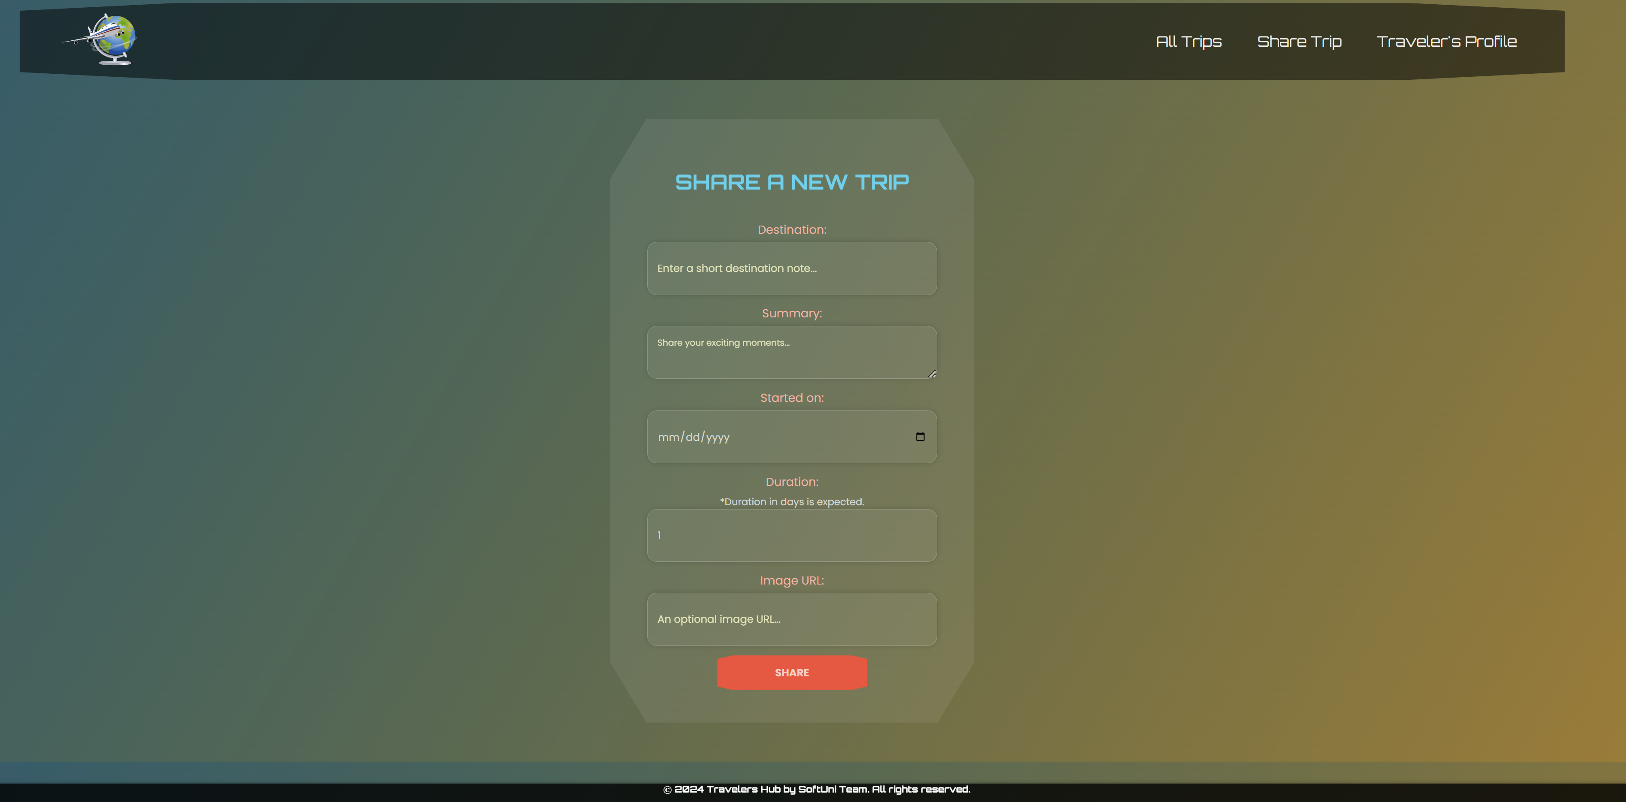

### Trip Details Page - 10p

**Template file**: **"details-trip.html"**

This page contains the selected **trip** information. It should have the following:

* The **trip's image** if suchis **provided**, otherwise displays a **default trip image** from resources(static/images/default-trip.jpg)
* The trip's **destination**
* The trip's **start date**. The **date is displayed** in the **format**: **"D d M Y"**
* The **trip's duration**
* The **trip's summary**
* An **"Edit"** button that leads to the **Edit Trip page**
* A **"Delete"** button that leads to the **Delete Trip page**

If a **trip image** has been **provided**:

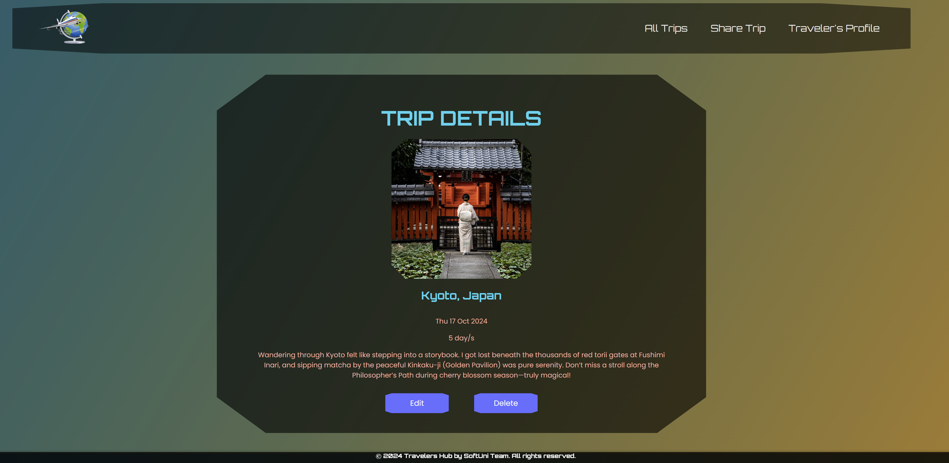

If there is **no trip image** **provided**, display the **default** one:

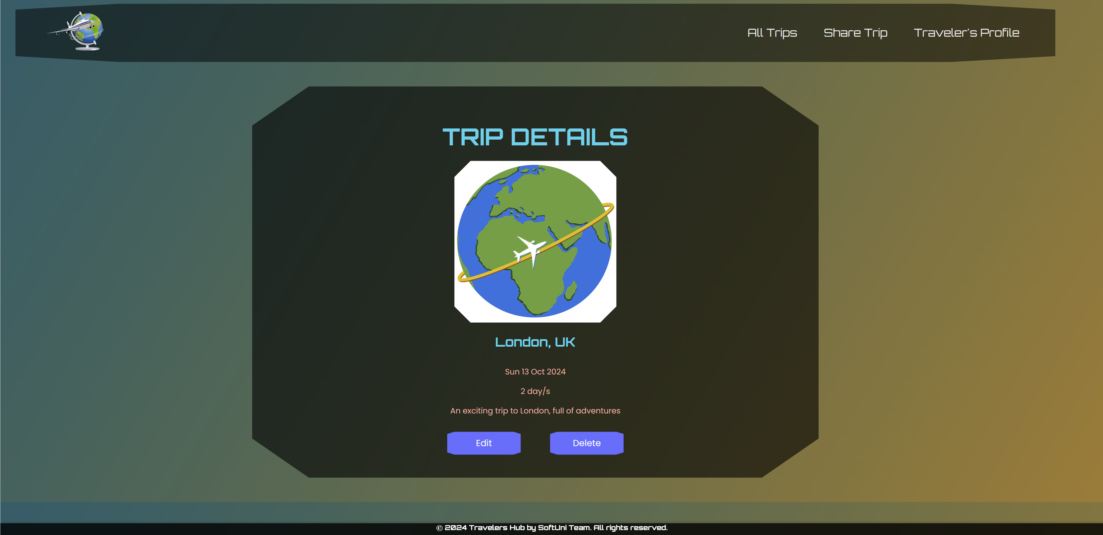

### Edit Trip Page - 10p

**Template file**: **"edit-trip.html"**

On the page, the **form** must be **pre-filled** with **information** about the **trip** you selected **to edit**.

Each field has a **label**: **"Destination:"**, **"Summary:"**, **"Started on:"**, **"Duration:"**, and **"Image URL:"**. The **help text** for the **duration field** is also displayed: **"*Duration in days is expected."**

When you click on the **"Edit"** button:

* If the **trip** is **successfully edited**,you should be redirected to the **All Trips** **page**.
* **Otherwise**, the form should show the **appropriate validation errors**.

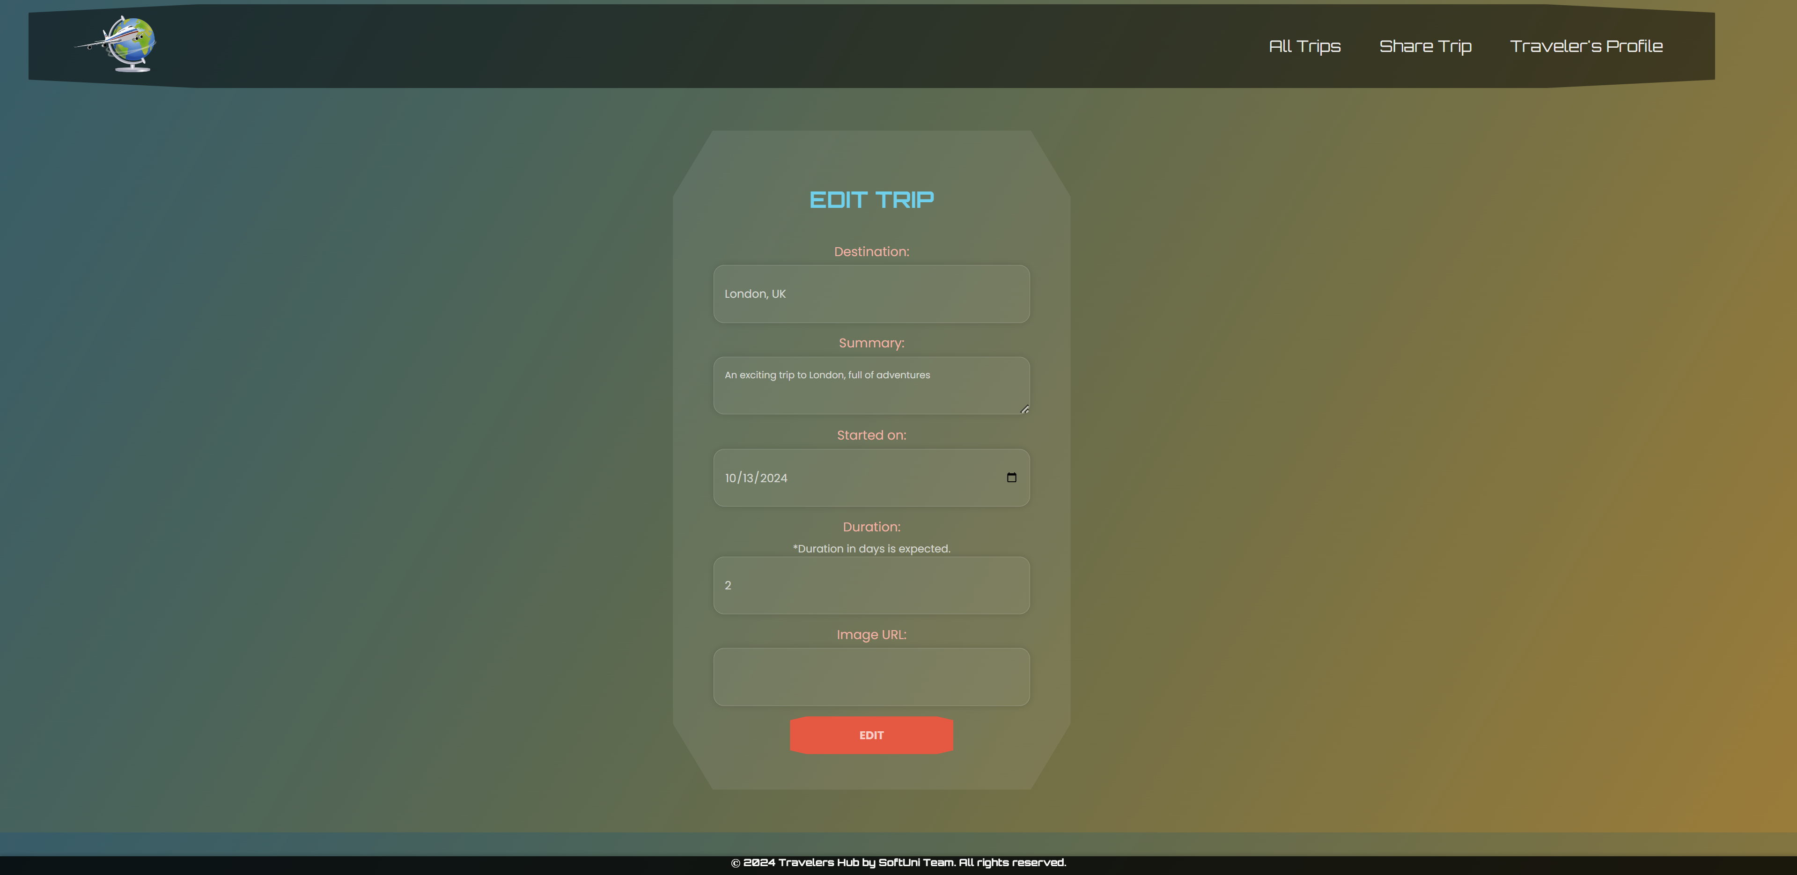

### Delete Trip Page - 10p

**Template file**: **"delete-trip.html"**

On the page, the **form** must be **pre-filled** with the **trip's information**, and **all the fields** should be **read-only**.

Each field hasa **label: "Destination:"**, **"Summary:"**, **"Started on:"**, **"Duration:"**, and **"Image URL:"**. The **help text** for the **duration field** is also displayed: **"*Duration in days is expected."**

When you click on the **"Delete"** button, the **trip** is **deleted from the database**, and you should be redirected to the **All Trips page**.

The deleted trip should be **no longer visible** in the **app**.

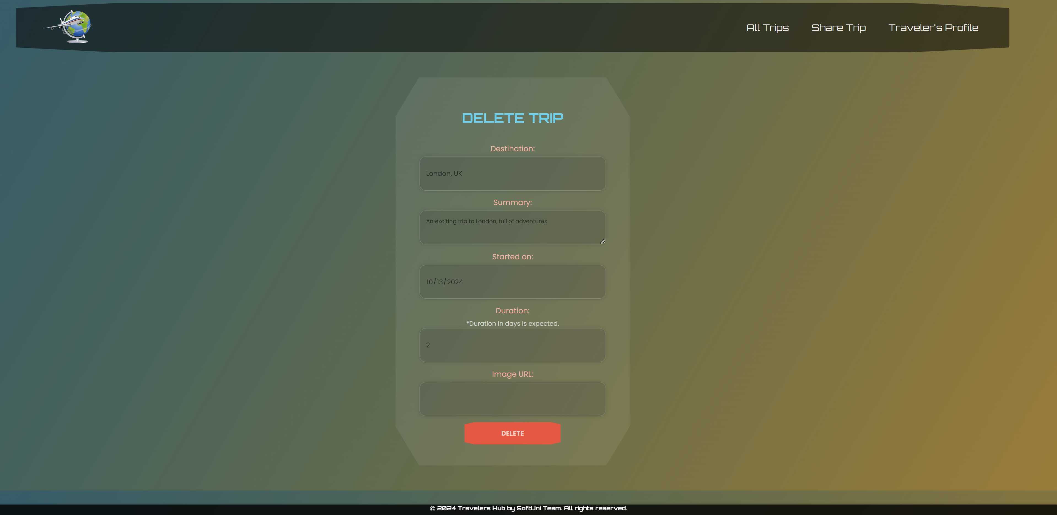

### Traveler's Profile Details Page - 10p

**Template file**: **"details-traveler.html"**

This page contains the **traveler's profile information**. It should have the following:

* A **default** **profile** **picture** from the resources folder (static/images/default-traveler.png)
* **Nickname**
* **Email** address and **Country**
* The **traveler's "about me" info** if such is **provided**, otherwise **skip it**
* All **shared trips** (**if any**, otherwise **skip the section**), **ordered by start date descending**, in the **format**: **"{destination}: {duration} day/s, started on: {start_date}"**
  + **Trips** are displayed in a **<ul>** element where **each trip** is in a **<li>** element.
* An **"Edit"** button that leads to the **Edit Traveler's Profile page**
* A **"Delete"** button that leads to the **Delete Traveler's Profile page**

If the **traveler has "about me" info and shared trips**:

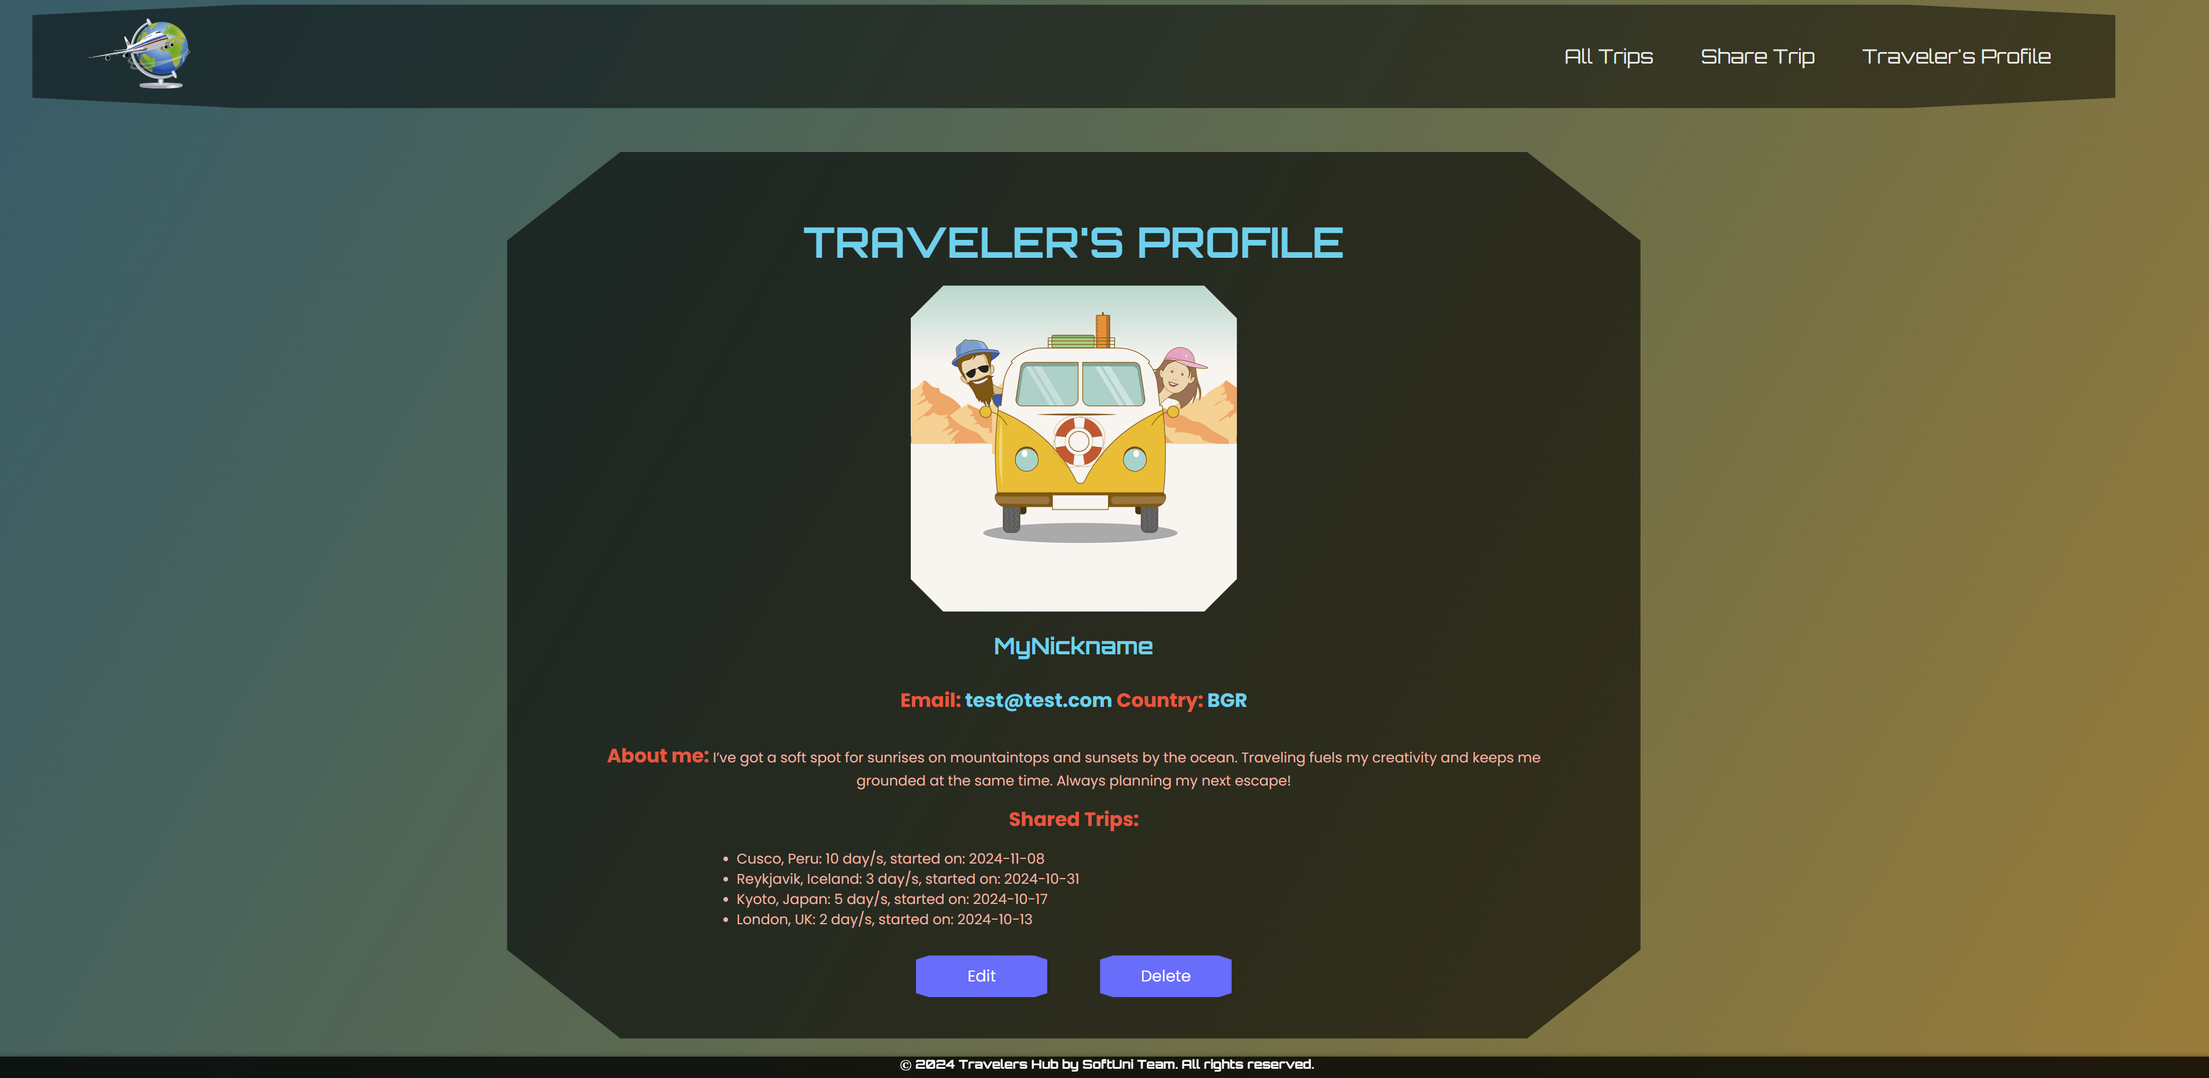

If there are **no trips** shared yet and **no traveler's "about me" info**:

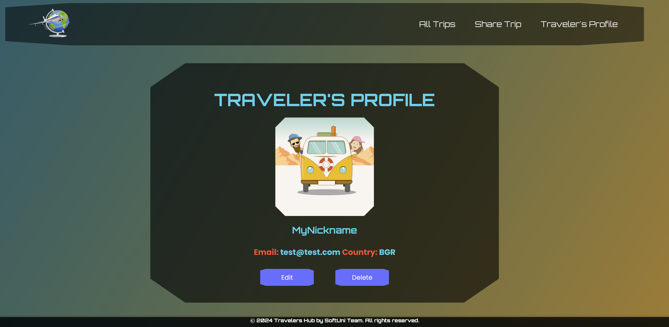

### Edit Traveler's Profile Page - 10p

**Template file**: **"edit-traveler.html"**

On the page, the **form** must be **pre-filled** with the **information** of the **traveler's** **profile** you want to **edit**.

The traveler's profile **edition form** has **fields** as shown below:

* A **"Nickname:"** field
  + The **help text** **"*Nicknames can contain only letters and digits."**
* An **"Email:"** field
* A **"Country:"** field
* An **"About me:"** field

**All** fields have **labels**.

When you click on the **"Edit"** button:

* If the profile is **successfully edited**,you should be **redirected** to the **Traveler's** **Profile Details page**.
* **Otherwise**, the form should show the **appropriate validation errors**.

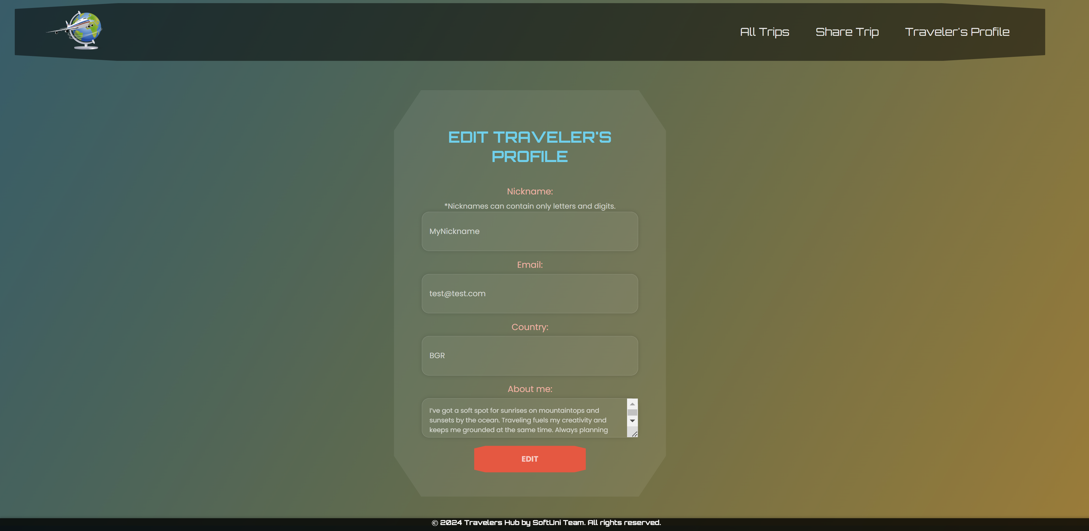

### Delete Traveler's Profile Page - 5p

**Template file**: **"delete-traveler.html"**

Deleting a traveler's profile should **delete** the **profile info** **and** **their shared trips**.

After **deletion**, the user should be redirected to the **Index page**.The **Index page** must havecorrect navigation links.

